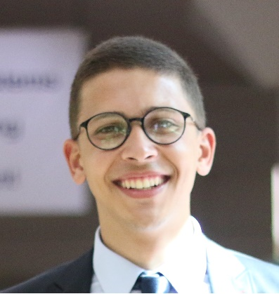
Mohamed Khaled Abdel Moneim.
01210336560 | mohamedkhaledshell@gmail.com
267 Evergreen Compound, Degla Gardens Road, Dr. Ahmed Zewail Road, Wahat Road, 6 of October, Cairo, Egypt.

CAREER OBJECTIVE
I am seeking a job opportunity in my field in a well-recognized organization where I could utilize and improve my skills at the same time associate with my society. Plus I want to increase my skills to support my career and being qualified to do more to my employer and the society.

EDUCATION

- Modern Sciences and Arts University (MSA). [2014 – 2018].
Bachelors of Computer Science.
Graduation Project: Very Good (B).
GPA 2.76.

- University of Greenwich. [2014 – 2018].
Bachelors of Computer Science.
UK GPA 2.36.

- Queen International School. [2000 – 2014].
Thanaweya Amma in English.
Mathematics.

EXPERIENCE

- Headway Program Graduate Intern. [Sep 2018 – Present].
In FabLab.
At Giza systems, New Cairo.

- Embedded System Academy At AMIT. [Sep 2018 – Present].

- Attending the One Million Arab Coder Nanodegree. [July 2018 – Present].
A Data Analyst Specialist.

- One Million Arab Coder Nanodegree. [Jan – Apr 2018].
A Front-End WEB expert.

- Summer internship at University of Greenwish. [Aug – Sep 2017].
At London, UK.
Robotics Course (using Arduino, C and Assembly languages).

- Summer Training at Giza Systems. [Aug – Sept 2016].
Network TTI Department (Technical engineer, Presales engineer).
https://www.linkedin.com/company/giza-systems
Trainer: Mohamed Hamdy.

PROJECTS:

- Maze Solving Robot. [Feb – Jul 2018].
It’s my graduation project. The main idea of it is to solve the original maze problem in the shortest time with the shortest path, Using Arduino, Sensors, motors for hardware and programing language “C” to make the Robot.

- Object Avoidance Robot and Object Flowing Robot. [Aug – Sep 2017].
we build and programed two robots one detect object and move away from it the other find the nearest object and flow it even if it was moving, Using Arduino, C, Assembly, Sensors, motors, and Bluetooth.

- Zigzag. [May 2017].
It’s a game app for IPhone in Swift using Xcode.
GitHub: https://github.com/mohamedkhaledshell/Zigzag.git

- Car Fixing. [Sep – Dec 2016].
Mobile application and website for fixing cars in Android, HTML, CSS, SQL and database using Android studio and Online studio.

- Faculty website. [Jan – May 2016].
We created a website from scratches for my faculty using HTML, CSS, JavaScript and Php.
GitHub: https://github.com/mohamedkhaledshell/webproject.git

SKILLS

Language Skills:
- Arabic (mother tongue).
- Excellent writing, reading and speaking in English.
- Have an educational background in French and German.
Computer Skills:
- Well known of C, C++, and C #.
- Well known of JavaScript.
- Well known of Git and GitHub.
- Well known of Swift (Xcode).
- Well known of Arduino and Robotics.
- Microsoft visual studio.
- Web Design (HTML, CSS, JS).
- Web Development.
- Adobe Photo shop CS5.
- Microsoft Office and Microsoft Windows.
- Well known of Adobe InDesign CS5.
- Good knowledge of Database SQL.
- Good knowledge of CCNA.
- Good knowledge of Android Studio.
INTERPERSONAL SKILLS:
- Team player.
- Easy to talk to.
- Technical Writing.
- Ability to work in Team.
- Good Time Management.
- Excellent presentation skills.
- Excellent communication skills.
- Eager to learn and work under pressure.
- Very helpful and love to share my knowledge.
PERSONAL INFORMATION:
Full Name: Mohamed Khaled Abdel Moneim Abdel Hafez.
Date of birth: 20th December 1996.
Military Status: Exempted.
Nationality: Egyptian.
https://github.com/mohamedkhaledshell
https://eg.linkedin.com/in/mohamedshell
https://wuzzuf.net/me/mohamedkhaledshell

